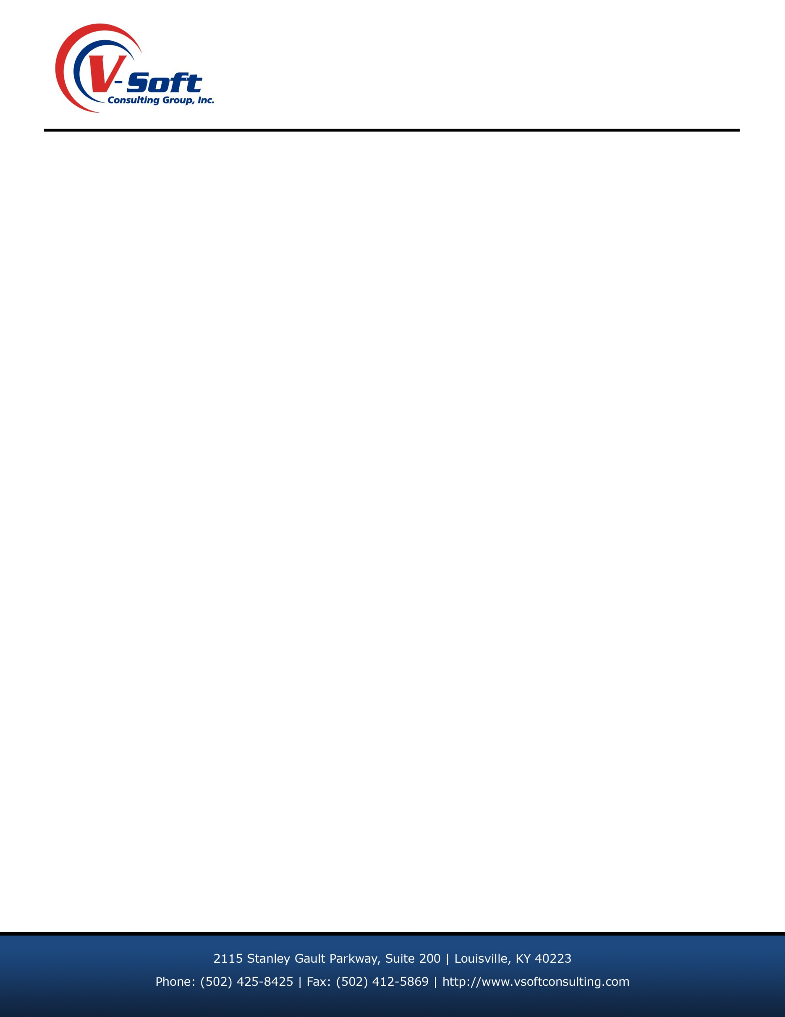
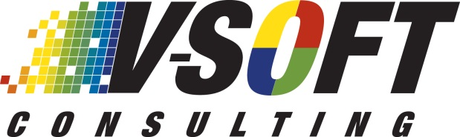

BIWEEKLY STATUS REPORT

<<Timesheet is updated by GCC Resource on a weekly basis>>
Resource Name: Anvesh Ananthula | Client: Wells Fargo N.A.
Biweekly Starting: June 15th 2017 | Biweekly Ending: Jun 30th 2017

CURRENT Projects:

# | Projects | Start Date. | Estimated Completion Date | % Comp.
1. | Gateway CRM | June 1st 2017 | NA | New Project 0%

Description of the Projects:

Gateway CRM: Gateway Customer relationship management (CRM) Portal which is between companies and wells Fargo. The Gateway Support Group is looking for a way to better manage the process of generating a request for Gateway ID numbers. To initiate the process, the Account must be set up in the system with key data elements identified. This is for the provisioning of API's based on a customers need. They currently have to do multiple steps, accessing multiple systems, quite a bit of "cutting and pasting" and very manual processes to address the LOB requests. It is believed that the required functionality can be managed in a fully-functional system capable of addressing their needs. It is also believed that a more "Self-Service" centric solution would allow the LOB to create those requests and have the Gateway support group more efficiently address the requests.

Current TWO WEEKS Tasks:

# | Tasks | Start Date | End Date
1. | Attended Weekly Gateway CRM Team meeting to review all on going tasks. | 06-15-2017 | 06-30-2017
2. | Initial design Demo to Business | 06-15-2017 | 06-30-2017
3 | Design for Company Setup form with Responsive Design | 06-15-2017 | 06-30-2017

NEXT TWO WEEKS Tasks:

# | Tasks | Start Date | End Date
1. | Integrate the company setup with CRM and write the business logic to handle companies at CRM Level. | 07-01-2017 | 07-15-2017
2 | Create API for access Global Companies data from ICIS Search | 07-01-2017 | 07-15-2017
3 | Design Search Form to get External Companies | 07-01-2017 | 07-15-2017


ISSUES/COMMENTS:
# | Description | Impact
1.
2.
3.
<<Issue # should match with Issue number in Issue Log>>

